Login to AWS Console

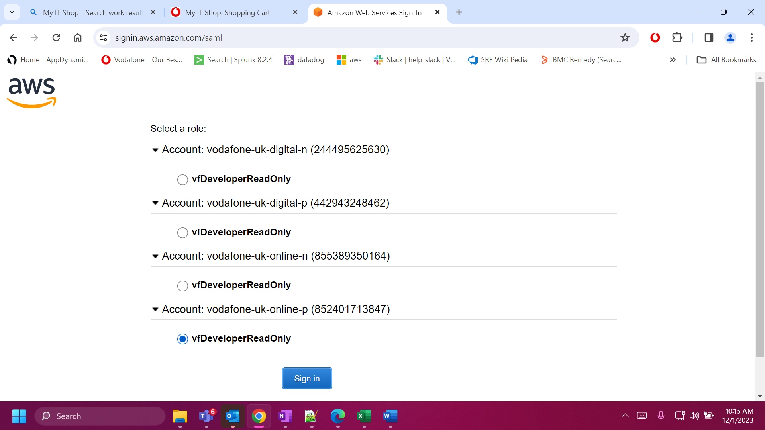

2. Navigate to EFS Service

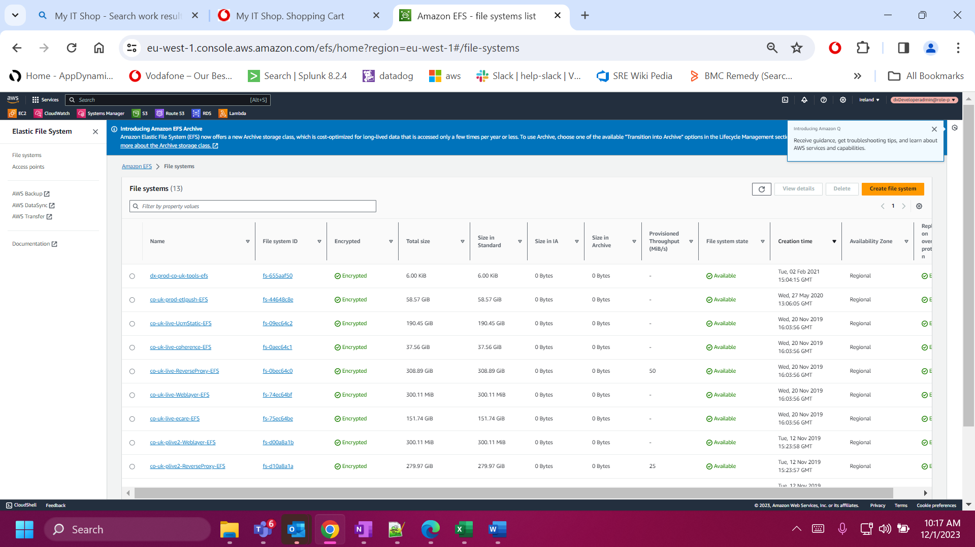

The following File systems needs to be Taken Backup in case of AMI Rollback for the Live environment

1. [co-uk-prod-etlpush-EFS](https://eu-west-1.console.aws.amazon.com/efs/home?region=eu-west-1#/file-systems/fs-44648c8e)
2. [co-uk-live-UcmStatic-EFS](https://eu-west-1.console.aws.amazon.com/efs/home?region=eu-west-1#/file-systems/fs-09ec64c2)
3. [co-uk-live-coherence-EFS](https://eu-west-1.console.aws.amazon.com/efs/home?region=eu-west-1#/file-systems/fs-0aec64c1)
4. [co-uk-live-ReverseProxy-EFS](https://eu-west-1.console.aws.amazon.com/efs/home?region=eu-west-1#/file-systems/fs-0bec64c0)
5. [co-uk-live-Weblayer-EFS](https://eu-west-1.console.aws.amazon.com/efs/home?region=eu-west-1#/file-systems/fs-74ec64bf)
6. [co-uk-live-ecare-EFS](https://eu-west-1.console.aws.amazon.com/efs/home?region=eu-west-1#/file-systems/fs-75ec64be)
7. [co-uk-prod-logs-efs](https://eu-west-1.console.aws.amazon.com/efs/home?region=eu-west-1#/file-systems/fs-1f55e0d4)
8. [dx-prod-co-uk-tools-efs](https://eu-west-1.console.aws.amazon.com/efs/home?region=eu-west-1#/file-systems/fs-655aaf50)

The following File systems needs to be Taken Backup in case of AMI Rollback for the PLive environment

1. [co-uk-plive2-Weblayer-EFS](https://eu-west-1.console.aws.amazon.com/efs/home?region=eu-west-1#/file-systems/fs-d00a8a1b)
2. [co-uk-plive2-ReverseProxy-EFS](https://eu-west-1.console.aws.amazon.com/efs/home?region=eu-west-1#/file-systems/fs-d10a8a1a)
3. [co-uk-plive2-UcmStatic-EFS](https://eu-west-1.console.aws.amazon.com/efs/home?region=eu-west-1#/file-systems/fs-d20a8a19)
4. [co-uk-plive2-ecare-EFS](https://eu-west-1.console.aws.amazon.com/efs/home?region=eu-west-1#/file-systems/fs-d30a8a18)
5. [co-uk-plive2-coherence-EFS](https://eu-west-1.console.aws.amazon.com/efs/home?region=eu-west-1#/file-systems/fs-d70a8a1c)

Now Navigate to AWS Backup Service

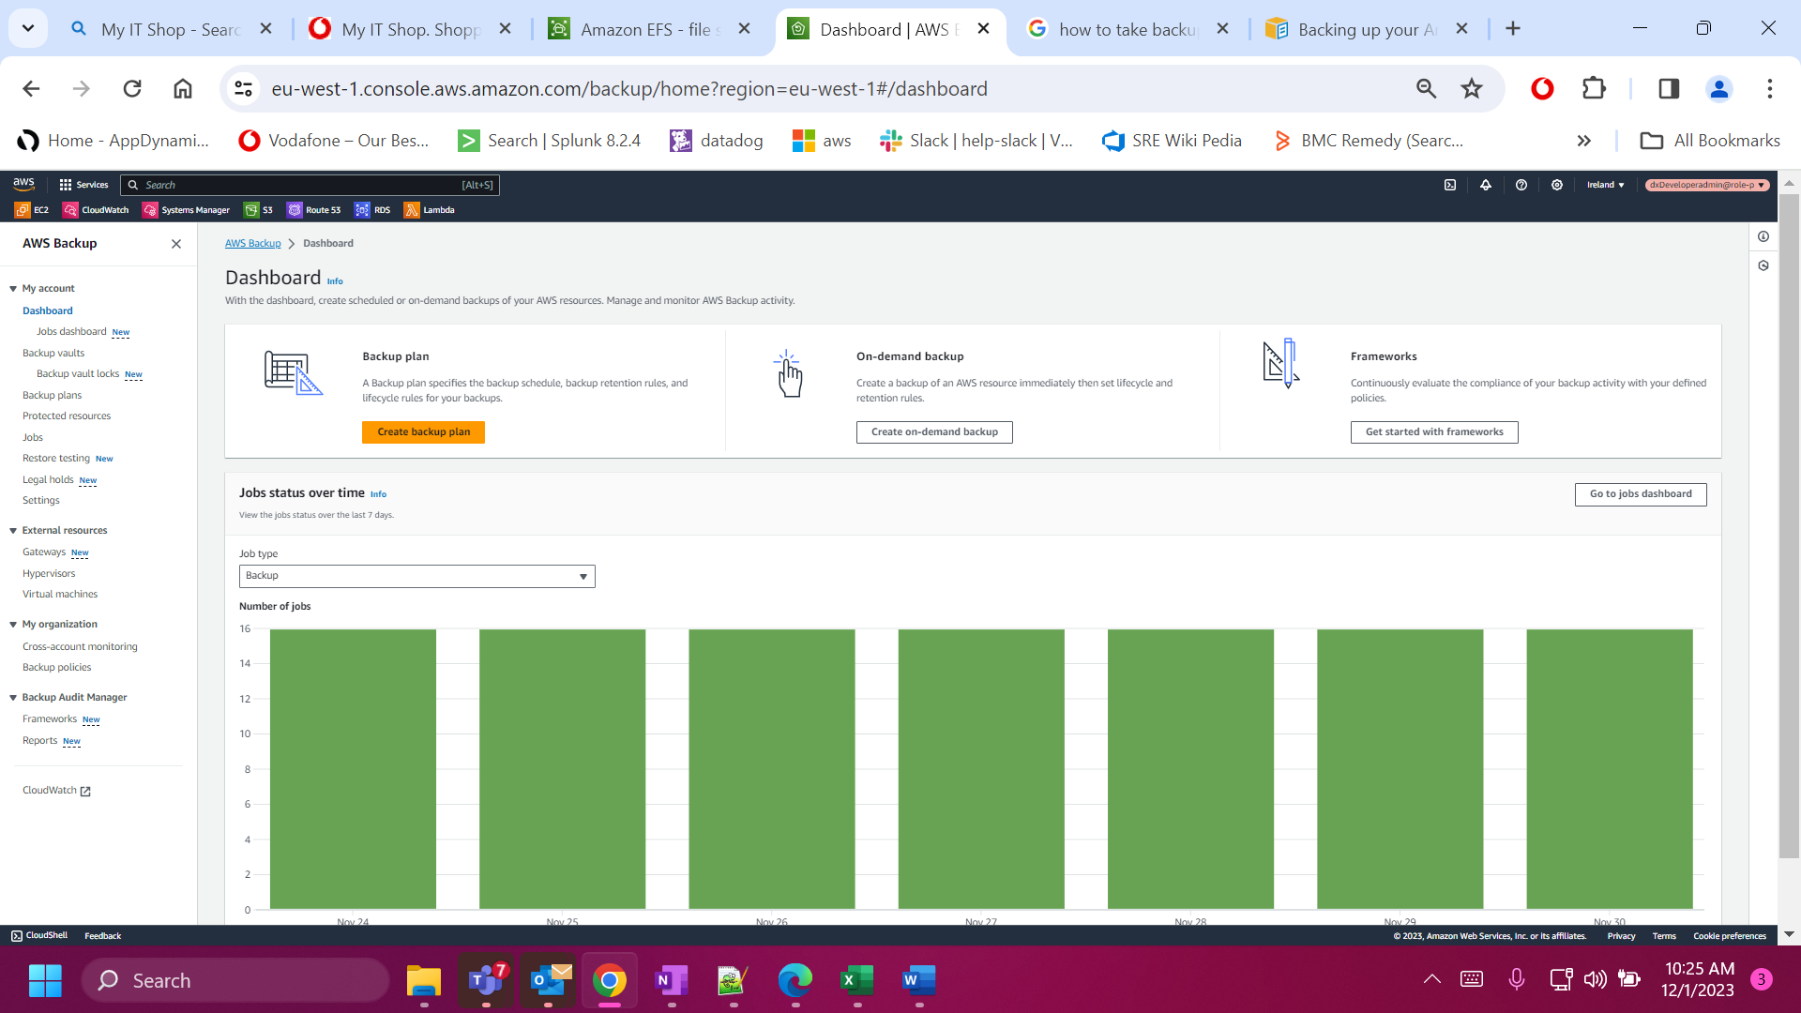

Select the Backup Vaults 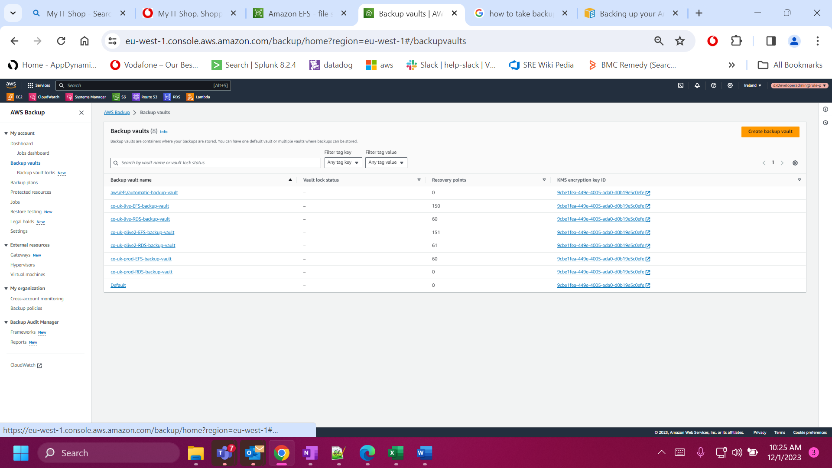

Now select the co-uk-live-EFS-backup-vault

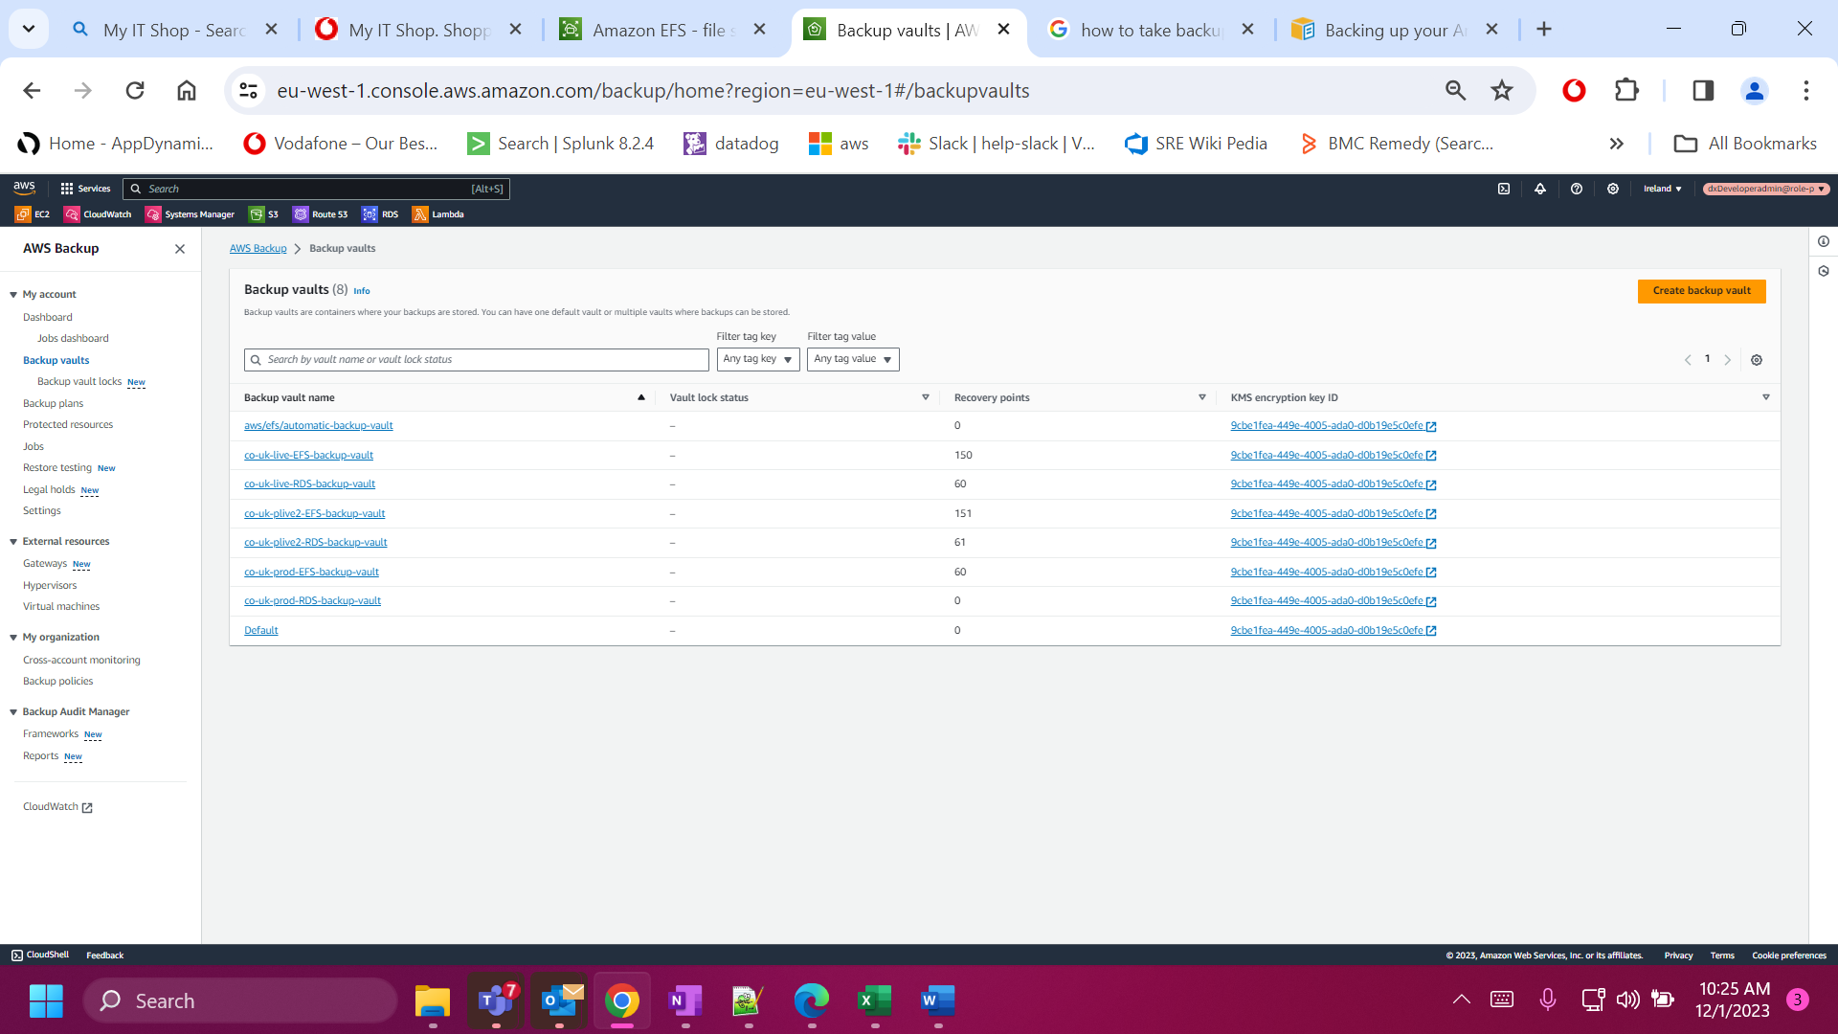

Under it we have all the servers related to EFS, we need to select the appropriate file system and click on actions and select the restore button

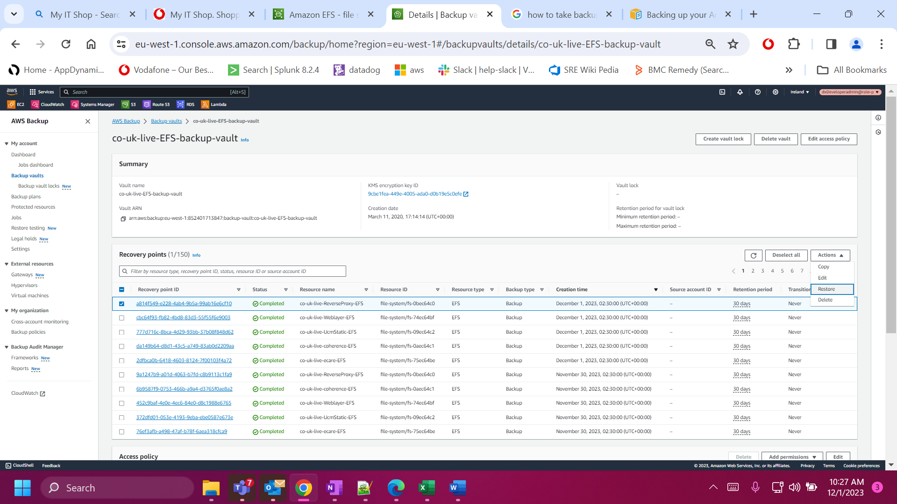

Now select the full restore click on restore backup button

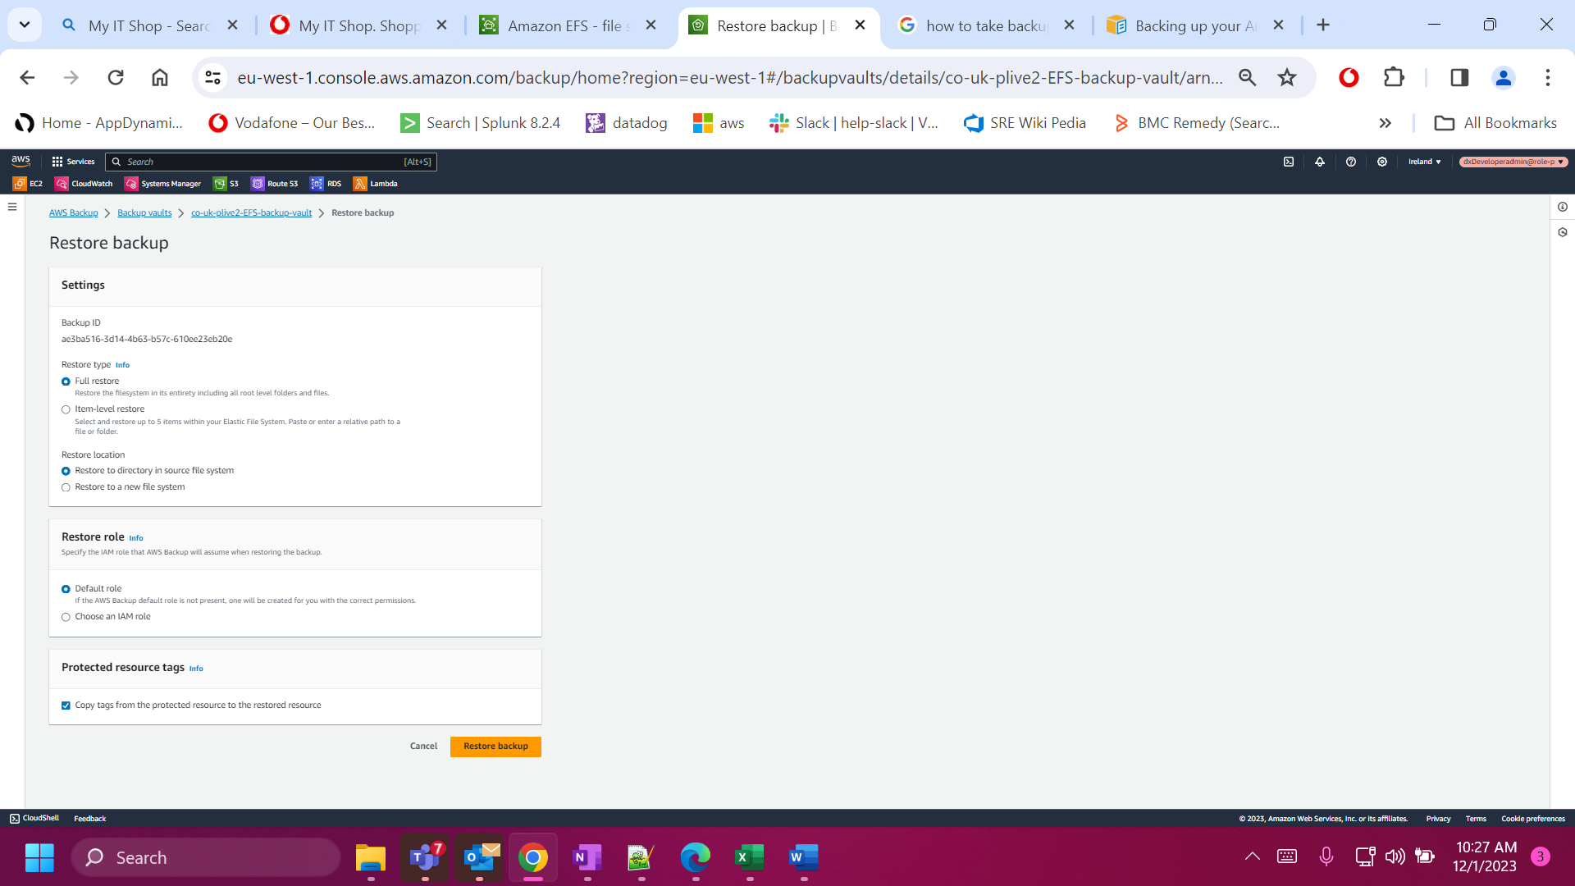

After taking the Backup we can confirm through the latest creation time as follows

